Note: The exam will be a quiz on Canvas, so bring your laptop. There will be all multiple choice questions, with 1 or more correct answers, including questions similar to the quizzes for each section on the course homepage, and calculation questions similar to the following, i.e., you select a correct answer and do not need to show the calculation process or explanations.

Question 1: Delays and Throughput (18 points) Consider the scenario in the figure to the right, in which (from the bottom up) three hosts and a local logging server (that stores information that is sent to it) are connected to a router and to each other by a 100 Mbps link, with an near-zero ms propagation delay. That router in turn is connected to another router over a 30 Mbps link with a 50 ms propagation delay, and that latter router is connected to two remote logging servers, each over a 20 Mbps link with a10 ms propagation delay.
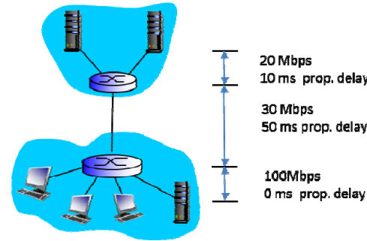
a) Suppose a host sends a logging message directly to one of the remote logging servers. The logging message is 10K bits long. What is the end-to-end delay from when the logging message is first transmitted by the host to when it is received at the remote server? Assume that the request goes directly to the server, that there are no queueing delays, and that node (router) packet-processing delays are also zero.
Answer: given the 10K bit packet, it takes .0005 secs to send this packet over a 20 Mbps link. 0.000333 secs to send over a 30 Mbps link, and .0001 secs over the 100 Mbps link. The total transmission time end-to-end is this .0009333 secs. The total propagation delay is 60 ms. Therefore the total end-end delay is .0609333 secs.
b) Assume that each of the three hosts generate logging messages at the same rate; each host is equally like to send a logging message to either of the two remote servers. No traffic is directed to the local logging server. What is the maximum rate at which the clients can send logging messages to the remote servers?
Answer: the link between routers is the bottleneck link, allowing 30 Mbps to be delivered to the two servers combined, or 15 Mbps to be delivered to each server. Since each message is 10K bits, this is 1.5K logging messages per second.

c) Now assume that the local logging server is ON and only one host is active (generating) logging messages and that host is only sending messages to one of the remote logging servers. Suppose that 50% of the logging messages are directed locally and the other 50% directed to this remote server. What is the maximum rate at which this host can generate and send logging messages (both local and remote combined, given there is a 50/50 ratio of local/remote transmissions) in this scenario?
Answer: The maximum rate at which the host can generate remote logging messages is 20 Mbps or 2K logging messages per second. Local messages can be generated that the same rate, so the overall rate is 40 Mbps or 4K logging messages per second.

Question 2: Delays, Throughput and Caches (18 points, 10 minutes) Consider the scenario in the figure below in which a server is connected to a router by a 100 Mbps link, with a 100 ms propagation delay. That router in turn is connected to two routers, each over a 25 Mbps link with a 200 ms propagation delay. A Gbps link connects a host and a cache (when present) to each of these routers; this link, being a local area network, has a propagation delay that is essentially zero. All packets in the network are 10,000 bits long.
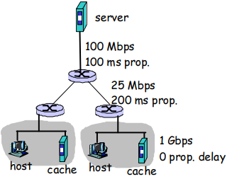
a) 4 points. What is the end-to-end delay from when a packet is transmitted by the server to when it is received at a host? Assume that there are no caches, that there is no queueing delay at a link, and that the node (router) packet-processing delays are also zero.
Answer: If all packets at 10,000 bits long, it takes 100 usec to send the packet over a 100Mbps link, 400 usec to send over a 25 Mbps link, and 10 usec to send over a gigabit link. The sum of the three link transmission times is thus 510 usec. The sum of the propagation delays is 200+100=300 msec. Thus the total end-end delay is 300.510 msec.
b) 3 points First assume that client hosts send requests for files directly to the server (i.e., the caches are off). What is the maximum rate at which the server can deliver data to a single client, assuming no other clients are making requests.
Answer: 25 Mbps, the bottleneck link speed.
c) 3 points Again assume that only one client is active, but now suppose the caches are HTTP caches and are turned on. A client HTTP GET is always first directed to its local cache. 50% of the requests can be satisfied by the local cache. What is the maximum rate at which this client can receive data in this scenario?
Answer: We assume that requests are serially satisfied. 50 % of the requests can be delivered at 25 Mbps and 50% of the requests can be delivered at 1 Gbps. So the average rate is 512.5 Mbps.
In general, suppose x of the requests can be delivered at 25 Mbps and 1-x of the requests can be delivered at 1 Gbps. The average rate is x*25Mbps + (1-x)*1Gbps.
d) 4 points Now suppose that the clients in both LANs are active and the HTTP caches are on, as in c) above. 50% of the requests can be satisfied by the local cache. What is the maximum rate at which each client can receive data, in this scenario?
Answer: the 25 Mbps remains the bottleneck link, which is not shared between clients. So the answer is the same as c) above. Note that we assume that the 100Mbps is shared at a fine grain, so that each client can get up to 50Mbps over that link.
e) 4 points . Now suppose the 100 Mbps link is replaced by a 25 Mbps link. Repeat question d) above in this new scenario.
Answer: The two clients must now share the 25 Mbps bottleneck link, each getting 12.5 Mbps. 50 % of the requests from a client are delivered at 12.5 Mbps and 50% of the requests can be delivers a 1 Gbps. So the average rate is 506.25 Mbps.

Question 3: Congestion Control and TCP (15 points, 10 minutes) Consider four Internet hosts, each with a TCP session. These four TCP sessions share a common bottleneck link - all packet loss on the end-to-end paths for these four sessions occurs at just this one link. The bottleneck link has a transmission rate of R. The round trip times, RTT, for all fours hosts to their destinations are approximately the same. No other sessions are currently using this link. The four sessions have been running for a long time. a) (4 points) What is the approximate throughput of each of these four TCP sessions? Explain your answer briefly.
Answer: R/4 since TCP shares bandwidth fairly.
b) (4 points) What is the approximate size of the TCP window at each of these hosts? Explain briefly how you arrived at this answer.
Answer. Recall that roughly throughput = W/RTT or W = throughput * RTT = R*RTT/4.
c) (4 points) Suppose that one of the sessions terminates. What is the new throughput achieved by each of the three remaining sessions? Briefly describe how this new throughput is reached (i.e., what do the TCPs in the remaining three hosts do that results in this new throughput being achieved).
Answer: R/3 since TCP shares bandwidth fairly
d) (3 points) Now suppose that one of the three hosts starts a second session that also crosses this bottleneck link. What is the throughput achieved (in aggregate) by the one host with two sessions, and by each of the two hosts with one session each?
Answer: each session will again get R/4, so the one host with two sessions will get R/2 in aggregate and the other two hosts will each get R/4.

Question 4: Subnetting(b). Consider the three subnets in the diagram below.
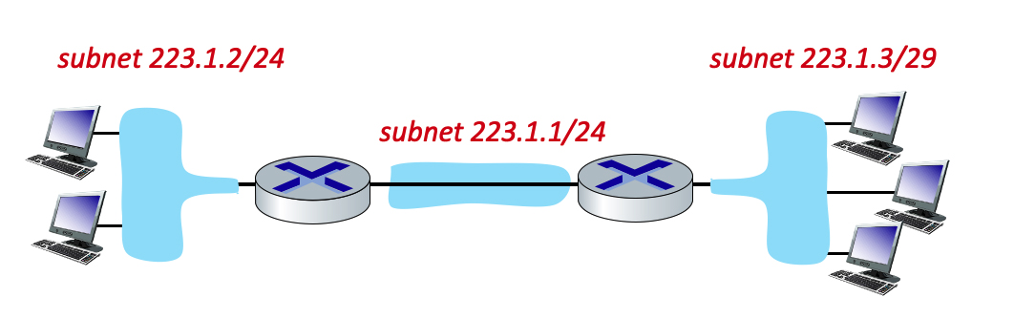
What is the maximum # of interfaces (hosts) in the 223.1.2/24 network?
Answer: In the 223.1.2/24 network, 24 bits are for subnet, 8 bits are for hosts, so maximum 256 hosts
What is the maximum # of interfaces (hosts) in the 223.1.2/29 network?
Answer: In the 223.1.2/29 network, 29 bits are for subnet, 3 bits are for hosts, so maximum 8 hosts

